Project Design Phase-II
Technology Stack (Architecture & Stack)

Date | 31 January 3035
Team ID | LTVIP2025TMID47516
Project Name | iRevolution: A Data-driven Exploration of Apple's iPhone Impact in India using Tableau
Maximum Marks | 4 Marks

Technical Architecture:
The Deliverable shall include the architectural diagram as below and the information as per the table1 & table 2
Example: Order processing during pandemics for offline mode
Reference: https://developer.ibm.com/patterns/ai-powered-backend-system-for-order-processing-during-pandemics/

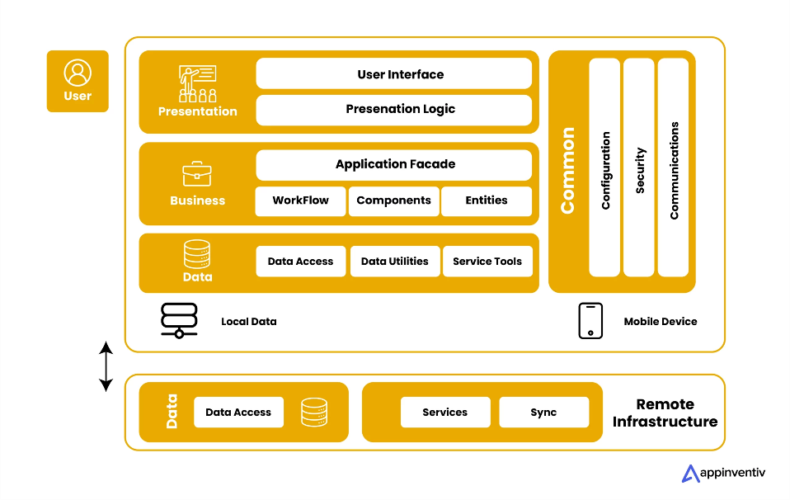
Table-1 : Components & Technologies:
S.No | Component | Description | Technology
1 | User Interface | How user interacts with the application (Web dashboard) | HTML, CSS, Flask (Jinja2)
2 | Application Logic-1 | Data Preprocessing & Analysis | Python (Pandas, NLTK)
3 | Application Logic-2 | Sentiment Analysis of social media data | TextBlob / VADER (Python)
4 | Application Logic-3 | Visualization rendering and filter logic | Tableau
5 | Database | Structured sales/demographic/social media data | SQL (DB2 Local)
6 | Cloud Database | Remote access & scalability of data storage | IBM DB2 on Cloud
7 | File Storage | Storage of reports and exports | Local Filesystem
8 | External API-1 | Optional integration of real-time Twitter data | Twitter API
9 | External API-2 | Optional use of news/sentiment APIs | News API, TextRazor
10 | Machine Learning Model | Sentiment classification | TextBlob/VADER Sentiment Model
11 | Infrastructure | App deployment and Tableau hosting | Flask (Localhost) + Tableau Public / Server

Table-2: Application Characteristics:
S.No | Characteristics | Technology
1 | Open-Source Frameworks | Flask, Pandas, NLTK, Tableau Public
2 | Security Implementations | Role-based Flask routing, IAM controls on DB2, HTTPS
3 | Scalable Architecture | 3-Tier Architecture: UI - Logic - DB
4 | Availability | Hosted dashboards on Tableau Public / Flask with fallback URLs
5 | Performance | Optimized SQL queries, Tableau extracts, local caching in Flask

